Department of Computer Science & Engineering

Microprocessor & Computer Architecture

MPCA-Laboratory/Assignment/Hands-on/Project

UE20CS252



NAME: HITHESH PATEL

SRN: PES1UG20CS166

SECTION: C

1. Execute the following programs on ARMSIM – PLUG-INS.

a. Set the LED to be light up.

b. Display hexadecimal digits [0-9, A-F] on the 8 segment display.

c. Move a string from LEFT to RIGHT on the LCD display panel.

a)

Code:

.Text

mov r0, #1

loop: swi 0x201

Ldr r4,=A

Ldr r4,[r4]

delay: sub r4, r4,#

cmp r4, #0

bne delay

add r0, r0, #1

cmp r0, #3

ble loop

swi 0x011

.Data

A:.word 84000

Output Screenshot:

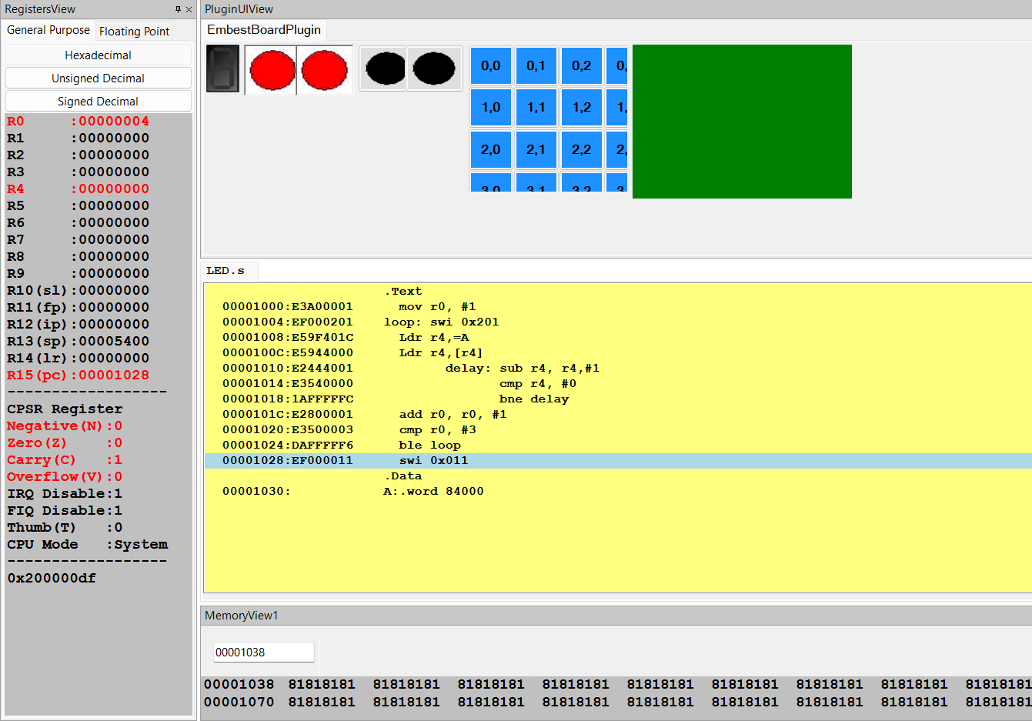

b)

Code:

.text

begin: mov r0, #0

mov r2,#0

again: swi 0x202 ; check whether black button pressed or not

cmp r0, #1 ; right button-upcounter

beq loop1

cmp r0, #2 ; left button- downcounter

beq loop2

b again

loop1: mov r5,#16

ldr r1,=zero

back1:ldrb r0, [r1]

swi 0x200 ; Set 8 segment display to light up

bl delay

add r1,r1,#1

sub r5, r5,#1

cmp r5, #0

bne back1

b again

loop2:

mov r5,#16

ldr r1,=F

back2: ldrb r0, [r1]

swi 0x200 ; Set 8 segment display to light up

bl delay

sub r1, r1, #1

sub r5, r5,#1

cmp r5, #0

bne back2

b again

delay: mov r4, #64000

loop3: sub r4, r4, #1

cmp r4, #0

bge loop3

mov pc, lr

.data

zero: .byte 0b11101101

one: .byte 0b01100000

two: .byte 0b01101110

three: .byte 0b11111010

four: .byte 0b00110011

five: .byte 0b10101011

six: .byte 0b10101111

seven: .byte 0b01110000

eight: .byte 0b11101111

nine: .byte 0b11100011

A: .byte 0b11100111

B: .byte 0b00101111

C: .byte 0b10001101

D: .byte 0b01101110

E: .byte 0b10001111

F: .byte 0b10000111

Output Screenshot:

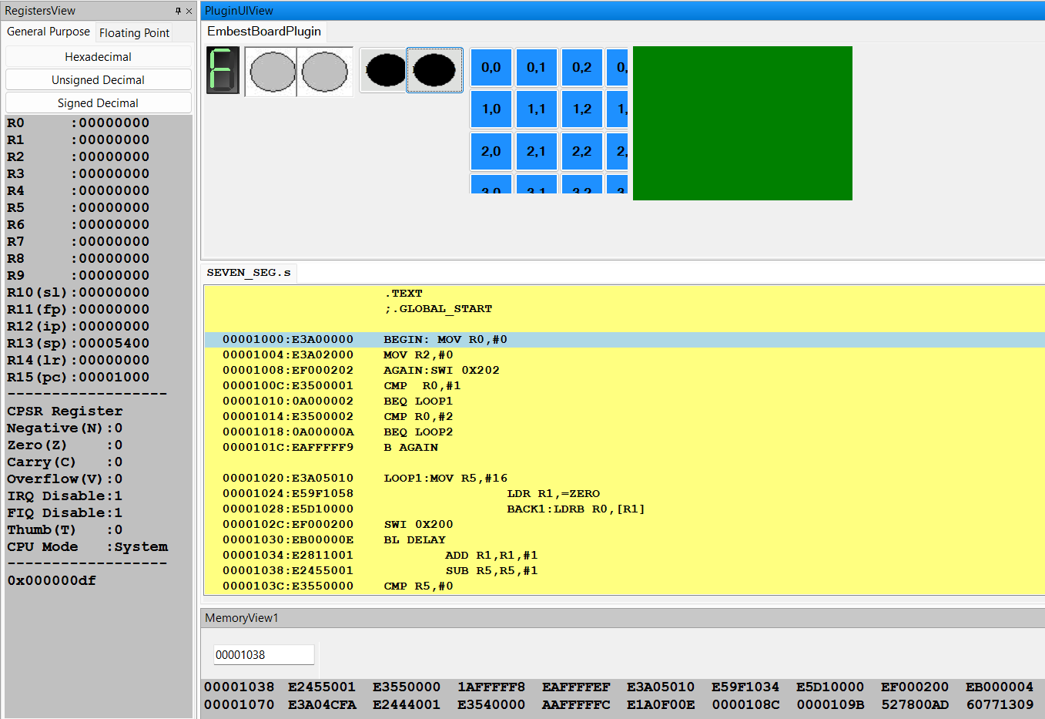

C)

Code:

.Text

mov r0 , #30 ; r0 = x

mov r1 , #7 ; r1 = y

mov r7 , #0

ldr r8 , =num

ldr r8 , [r8]

ldr r2 , =str

loop:

swi 0x204 ; display a string on the screen (R2: address)

bl sum

cmp r0 , #0

subne r0 , r0 , #1

swieq 0x11

b loop

sum: cmp r7 , r8

addne r7 , r7 , #1

bne sum

swi 0x206

mov r7 , #0

mov pc , lr

.Data

str: .asciz "PESU"

num: .word 15000

Output Screenshot:

